## CODING AND SOLUTION

|  |  |
| --- | --- |
| **Project Name** | **Customer Care Registry** |
| **Team ID** | **PNT2022TMID17200** |
| **Project Domain** | **Cloud Application Development** |

**Admin assigning an agent to a ticket:**

Code:

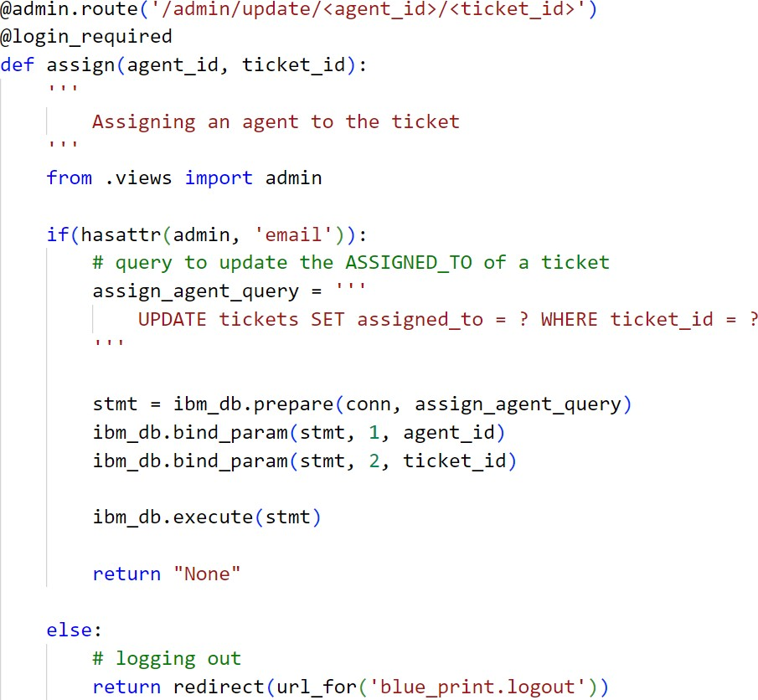

Explanation:

* + - Usercreatesaticketbydescribingthe query
    - Adminviewsthenewlycreatedticket inthedashboard
    - Inthedropdowngiven,adminselectsanagent
    - Onceselected,usingfetch()therequestissenttothe server
    - TherequestURLcontainsboththeTicketID andtheselectedAgentID
    - UsingtheshownSQLquery,theassigned_tocolumnoftheticketstableisset toagent_idwheretheticket_idcolumn=ticket_id
* Then,thedashboardoftheadmingetsrefreshed

## Customer closing a ticket:

Code:

## 

Explanation:

* + - Usercreatesaticketbydescribingthe query
    - Adminassignsanagenttothisticket
    - Thecustomerandtheagent,chatwith eachother,intheviewofclearingthecustomer’sdoubts
    - Oncethecustomerissatisfied,thecustomerdecidestoclosetheticket
    - Usingfetch() the requestissenttotheserver.Therequested URLcontainstheTicketID
    - UsingtheshownSQLquery,thestatusoftheticketissetto“CLOSED”
    - Thustheticketisclosed
    - Thenthecustomergetsredirectedtotheall-tickets page

## Database Schema:

A database schema is the skeleton structure that represents the logical view of the entiredatabase. It defines how the data is organized and how the relations among them are associated. Itformulatesalltheconstraints thataretobeappliedonthedata.

Adatabaseschemadefinesitsentitiesandtherelationshipamongthem.Itcontainsadescriptive detail of the database, which can be depicted by means of schema diagrams. It’s thedatabase designers who design the schema to help programmers understand the database and makeituseful.

